Interactive Whiteboard

**Model：**ZAX-YJ86-ETXR

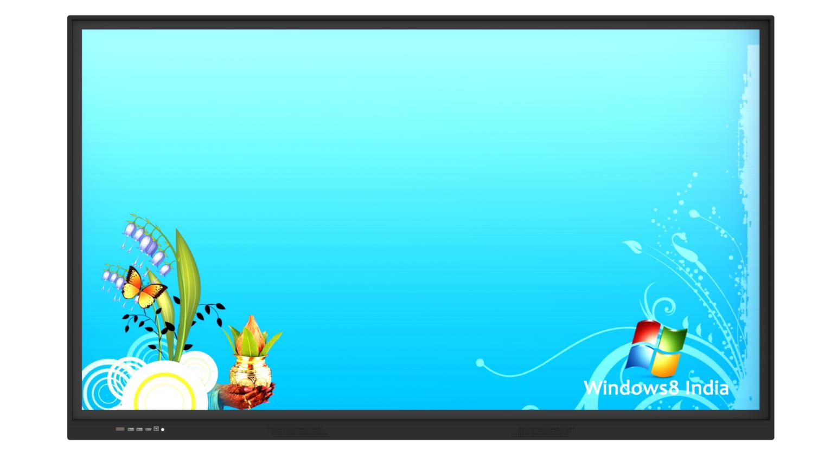

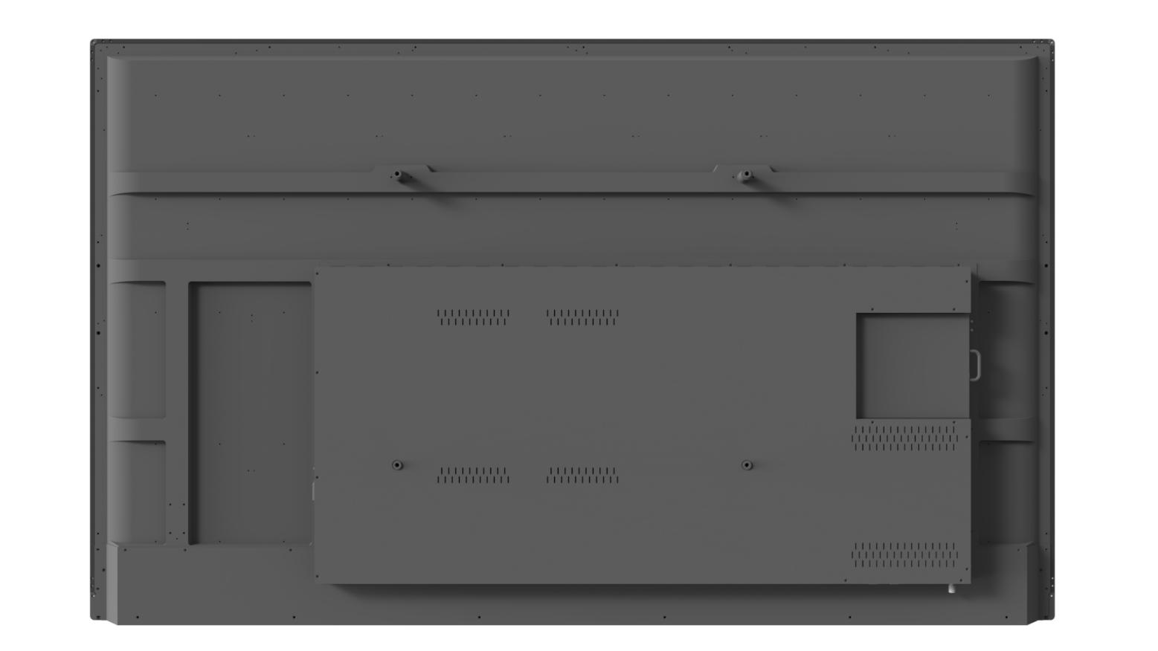

|  |  |
| --- | --- |
| **Android system hardware configuration** | |
| Main chip | HI37560V560 |
| CPU | Duad-core Cortex-A55@1200Mhz |
| RAM | 2GB |
| ROM | 16GB |
| System version | Android 9.0 |
| TV function | Wired TV view and play function  USB multimedia file playback function |
| Touch function | Support 20 points PC touch operation  Supports image zoom in/out and rotation  Support each signal source switch, touch function available  When each signal source is displayed, you can control the signal source and volume by touching the menu |
| Other function | Sleep timing, off memory  Support remote control instead of keyboard, achieve F1~F12 key function, remote TV power on function support touch menu, achieve back key, menu operation, task preview, channel switch, volume adjustment, quick electronic whiteboard operation and other functions  Support clicking any signal source on the system home page  Support remote control child lock function  Support wireless wifi, wired LAN  Support the front button one key switch computer, TV, one key computer reset and home button functions |
| **Main board input/output ports** | |
| USB input | 5ch（Type-A USB2.0 x4ch, include front USB2.0x2ch, USB3.0x1) |
| TOUCH input | 2ch (Type-B For HDMI Touch, include front 1ch) |
| Audio input | 1ch PC-VGA audio |
| Audio output | 1ch analog earphone (mini 3 to 1) |
| Extend storage | 1ch (SD card standard socket) |
| Network input | * 1ch standard RJ45 Ethernet network port * 1ch wireless 2.4G Wi-Fi |
| Integrated control port | 1ch RS232 port |
| Video input | * 1 input VGA * 3 input HDMI IN(include front 1ch) |

|  |  |  |
| --- | --- | --- |
| **Display Performance Specs** | | |
| Backlight type | DLED | |
| LED life | 50000h | |
| Display size (mm) | 1871.4x1053.6 | |
| Physical resolution | 4K（3840 x 2160） | |
| Peak Brightness | 320cd/㎡-20 | |
| Dynamic contrast | 5000: 1 | |
| View angle | H/V：178/178 degree | |
| Aspect ratio | 16:9 | |
| Display color | 10Bit, 16.7M | |
| Fresh frequency | 60HZ | |
| Display protection | 4mm full tempered vandal proof glass | |
| **Touch Specs** | | |
| Touch embedded method | embedded all in one | |
| Touch sensor tech | IR sensor recognition touch technology (20 points) | |
| Handwriting | Finger, touch penand other diameter not less than 5mm non transparent object(Multi-points 8mm) | |
| Cursor speed | 120 point/s | |
| location accuracy | Over 90% touch area ±2mm | |
| Touch resolution | 32767*32767 | |
| Touch times | theoretically no limits | |
| PC response | System auton recognition; ≤15ms | |
| Drive program | Free drive | |
| **Electronic performance** | | |
| Power input | AC 180-240V 50/60Hz | |
| Device power consumption（not include OPS） | 300-350W | |
| Speaker power | Stereo mixed dual-channel class-D power amplifier output, rated power: 2x10W  （L+R / 8Ω）of THD+N≤10%@1KHz (Audio Input：0.5VRMS） | |
| **Smart Board** | | |
| Smart writing board | | 5d2a0af2abba2bdcc3babab20f94350 |
| scan meeting content | | b7edeb1bf28453024315b8cea5e10b6 |
| Wireless miracast:  .One key to wireless screen projection  .Support touch sending, realize multi-screen interaction. | 842d1a6aae98d5aca77dda94a662f44 | |

|  |  |  |  |  |  |
| --- | --- | --- | --- | --- | --- |
| **Structure Size** | | | | | |
| Device size (L×H×T) | L1964xH1174.4xW94.5 | | | | |
| Package size(L×H×T) | L2105xH1325xW225 | | | | |
| Net weight（KG） | 70KG | | | | |
| Gross weight（KG）(not include wooden case or pallet) | 93KG | | | | |
| wall mount size | L850xH500xT45mm | | | | |
| Wall mount hole size | H600 xV600mm | | | | |
| Wall mount screw size | M8xL25x4 pcs | | | | |
| **Packing list** | | | | | |
| 75inch interactive panel | | | | 1pc | |
| Remote controller | | | | 1pc | |
| Touch pen | | | | 1pc | |
| User manual | | | | 1pc | |
| Power cable | | | | 1pc | |
|  | | 6bea8a8c9eef15c3eacad82802b2d34 | 6dd36cc14e5c8b597f4174e89155327 | | d666264e62a12cb82b8816c14cc76e3 |

# Size Drawing

## C:\Users\DELL\Desktop\8b843370e43466ed1c87aa418a689c2.png8b843370e43466ed1c87aa418a689c2

# Wall mounts size

|  |  |  |  |  |
| --- | --- | --- | --- | --- |
| Name | specs | qty | material | Remark |
| chassis fix plate | 850*195*31mm | 1 | SPCC | Max load 100kg |
| hook mounting plate | 600*30*12mm | 2 | SPCC | Max load 100kg |
| 4f3ccf37b457ae355ecb1bd588d48b5wall mount thickness 43MM | | | | |

|  |  |  |  |
| --- | --- | --- | --- |
| **OPS** | | | |
| CPU | Intel Core i3 | Intel Core i5 | Intel Core i7 |
| Chip group | Intel chip group | | |
| Storage | 4G+128G | | |
| Display card | Intel | | |
| Interface | 2 input USB2.0, 2 input USB 3.0, 1 input RJ45, 1 input HDMI, 1 input VGA output, 1 input MIC input, support wifi; | | |
| OS | Windows 7, 10 operation system | | |