55 inch LED-DID Splicing Video Wall Unit (16:9)

**Model:** ZAX-55PJ017P-LED/B

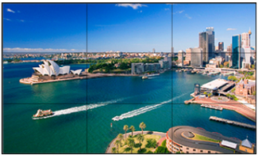

**Feature:**

* Original BOE DID Screen, high brightness, wide viewing, good stability;
* Embedded integrated splicing processors, good performance;
* Support 3D digital comb filter and MPEG digital image noise reduction, with high definition graphics;
* 5ms short response time, images without trailing;
* Wide viewing angle 178° , and high definition graphics seen from any angle;
* Aspect Ratio 16:9;
* DLED backlight;
* 24/7 working time;
* Each screen’s backlight brightness, color and brightness can be consistent for a long time.

**Specification:**

|  |  |
| --- | --- |
| Screen  Size | 55inch |
| Aspect Ratio | 16: 9 |
| Visible Size | 1209.6mm (H)*680.4mm(V) |
| Panel | TFT LED |
| Max resolution | 1920*1080 |
| Display Color | 16.7M |
| Pixel Pitch (mm) | 0.630 (H)*0.630(V) |
| Brightness | 500cd/㎡ |
| Contrast | 1200: 1 |
| Viewing Angle H/V) | 178°(H)/178°(V) |
| Response Time | 5ms |
| Seam | ≤1.7mm |
| Lamp Life | > 50000 Hours |
| Composite video input | 1ch BNC |
| DVI Input | 1CH DVI |
| HDMI Input | 1CH HDMI |
| VGA input | 1ch VGA |
| USB input | 1ch |
| RS232 Signal Control | 1CH Input (RJ45), 2CH loop out (RJ45) |
| Color System | PAL/NTSC |
| Compatible HD/SD and HDMI Input | 400i/P, 576i/P, 720P, 1080i/1080P |
| 3D Comb Filter | Support |
| MPEG Noise Reduction | Support |
| Splicing | Multi-Screen |
| Splicing Function | Windowing, Screen Crossing, Roaming |
| Matrix Joint Control | Support |
| AUTO Reproduction Ratio | Support |
| Remote Controller | Optional |
| Power Supply | AC 100~240V, 50/60Hz |
| Watt | < 200W |
| Dimension | 1211.3mm Х 682.1mm Х 65mm |

